Assignment 1

Nikitha Chigurupati

9/19/2022

#1. Installed the ISLR Library using the command install.packages(ISLR)

#2.Calling the ISLR Library, Summary of Carseats and Finding the number of rows.

library(ISLR)

## Warning: package 'ISLR' was built under R version 4.1.3

summary(Carseats)

## Sales CompPrice Income Advertising   
## Min. : 0.000 Min. : 77 Min. : 21.00 Min. : 0.000   
## 1st Qu.: 5.390 1st Qu.:115 1st Qu.: 42.75 1st Qu.: 0.000   
## Median : 7.490 Median :125 Median : 69.00 Median : 5.000   
## Mean : 7.496 Mean :125 Mean : 68.66 Mean : 6.635   
## 3rd Qu.: 9.320 3rd Qu.:135 3rd Qu.: 91.00 3rd Qu.:12.000   
## Max. :16.270 Max. :175 Max. :120.00 Max. :29.000   
## Population Price ShelveLoc Age Education   
## Min. : 10.0 Min. : 24.0 Bad : 96 Min. :25.00 Min. :10.0   
## 1st Qu.:139.0 1st Qu.:100.0 Good : 85 1st Qu.:39.75 1st Qu.:12.0   
## Median :272.0 Median :117.0 Medium:219 Median :54.50 Median :14.0   
## Mean :264.8 Mean :115.8 Mean :53.32 Mean :13.9   
## 3rd Qu.:398.5 3rd Qu.:131.0 3rd Qu.:66.00 3rd Qu.:16.0   
## Max. :509.0 Max. :191.0 Max. :80.00 Max. :18.0   
## Urban US   
## No :118 No :142   
## Yes:282 Yes:258   
##   
##   
##   
##

nrow(Carseats)

## [1] 400

#3.Finding the Maximum Value of Advertising attribute.

max(Carseats$Advertising)

## [1] 29

#4.Finding the IQR Value of Price attribute.

IQR(Carseats$Price)

## [1] 31

#5. Plotting the Sales over Price and finding the correlation.

library(ggplot2)

## Warning: package 'ggplot2' was built under R version 4.1.3

## Warning: replacing previous import 'lifecycle::last_warnings' by  
## 'rlang::last_warnings' when loading 'pillar'

ggplot(Carseats) +  
 aes(  
 x = Sales,  
 y = Price  
 ) +  
 geom_point(shape = "circle", size = 1.2, colour = "#112446") +  
 theme_minimal()

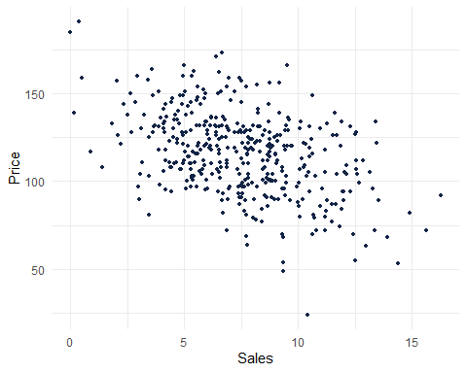

#As we see a downward slope or negative slope, this indicates that if Sales increases the Price decrease and vice-Versa.

cor(Carseats$Price, Carseats$Sales)

## [1] -0.4449507

#There is a Negative correlation between sales and price.